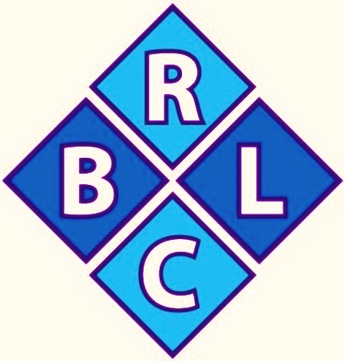
2019
SUMMER FUN DAYS

“Get Ready, Get Set, Have Fun”

Summer Fun Day Camp
- Hot Breakfast & Lunch Daily
- Creative Arts & Crafts
- Inspirational Time
- Exercise/Outdoor Activities
- Academic Enrichment & Life Skill Training
- Weekly Exploration Outage
- (Ages 5years to 16 years of age)
- 9:00 a.m.-1:00 p.m. – Tues. Wed. & Thursday

Will You Sponcer a Child? All donations are tax deductible.
COME JOIN US!!!!

(Ages 5 yrs. to 16 yrs.)
Summer Fun Day Begins: June 25th – August 1st
Sessions-1 (June 25th-July 11th) ---- Session 2 (July 16th-July 31st)

9:00a.m.-1:00p.m.- Tuesday, Wednesday & Thursday. Can you help with the sponsorship so that we can serve more low income children? This program has proven to be the most valuable to parents and the children. Last year there were more than 70 different campers that came. All parents are asked to donate $25.00 to match the $40.00 sponsorship donation made by the sponsors.
If you can help with the outreach it will be greatly appreciated. All sponsors names and businesses will be placed on a banner during the course of the camp and paced in the center until next year.

We DO NOT discriminate or turn any child away that wants to participate.
For camp information call 704-826-8737. Mon-Thurs. (9:00a.m.-5:00p.m.) or check out our website at www.burnsvillelc.org
Thank You for your support!
Print Sponsor’s Name: ______________________________________________________________

Circle One & Print Business Name, Church’s Name, Individuals Name, In Honor or Memory of:
_________________________________________________________________________________
Mailing Address: ___________________________________________________________________
Visit: www.burnsvillelc.org or check us out on .

